12. CODE 1
import matplotlib.pyplot as plt

# Example monthly temperature data (in °C)
months = ["Jan", "Feb", "Mar", "Apr", "May", "Jun",
"Jul", "Aug", "Sep", "Oct", "Nov", "Dec"]

temperature = [15, 17, 20, 24, 28, 30, 32, 31, 29, 25, 20, 16]

plt.plot(months, temperature)
plt.title("Monthly Temperature Data (Line Plot)")
plt.xlabel("Months")
plt.ylabel("Temperature (°C)")
plt.grid(True)
plt.show()
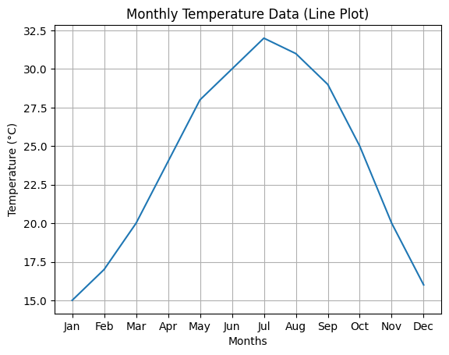
CODE 2
import matplotlib.pyplot as plt

# Example monthly rainfall data (in mm)
months = ["Jan", "Feb", "Mar", "Apr", "May", "Jun",
"Jul", "Aug", "Sep", "Oct", "Nov", "Dec"]

rainfall = [80, 60, 70, 50, 40, 90, 150, 160, 120, 70, 60, 85]

plt.scatter(months, rainfall)
plt.title("Monthly Rainfall Data (Scatter Plot)")
plt.xlabel("Months")
plt.ylabel("Rainfall (mm)")
plt.grid(True)
plt.show()
